**SQL ASSIGNMENT-2**

**QUESTIONS:**

**PART-1:**

The Products table contains details about products, including their names, categories, and unit

prices. It provides reference data for linking product information to sales transactions.

Query:

-- Create Products table

CREATE TABLE Products (

product_id INT PRIMARY KEY,

product_name VARCHAR(100),

category VARCHAR(50),

unit_price DECIMAL(10, 2)

);

-- Insert sample data into Products table

INSERT INTO Products (product_id, product_name, category, unit_price) VALUES

(101, 'Laptop', 'Electronics', 500.00),

(102, 'Smartphone', 'Electronics', 300.00),

(103, 'Headphones', 'Electronics', 30.00),

(104, 'Keyboard', 'Electronics', 20.00),

(105, 'Mouse', 'Electronics', 15.00);

1. Retrieve all columns from the product table.

2. Retrieve the product_name and unit_price from the Products table.

3. Filter the Products table to show only products in the 'Electronics' category.

4. Retrieve the product_id and product_name from the Products table for products with a

unit_price greater than $100.

5. Calculate the average unit_price of products in the Products table.

6. Retrieve product_name and unit_price from the Products table with the Highest Unit Price7. Retrieve the product_name and unit_price from the Products table, ordering the results by

unit_price in descending order.

8. Retrieve the product_name and unit_price from the Products table, filtering the unit_price to

show only values between $20 and $600.

9. Retrieve the product_name and category from the Products table, ordering the results by

category in ascending order.

**PART-2:**

The Sales table records information about product sales, including the quantity sold, sale date,

and total price for each sale. It serves as a transactional data source for analyzing sales trends.

Query:

-- Create Sales table

CREATE TABLE Sales (

sale_id INT PRIMARY KEY,

product_id INT,

quantity_sold INT,

sale_date DATE,

total_price DECIMAL(10, 2)

FOREIGN KEY (product_id) REFERENCES Products(product_id)

);

-- Insert sample data into Sales table

INSERT INTO Sales (sale_id, product_id, quantity_sold, sale_date, total_price) VALUES

(1, 101, 5, '2024-01-01', 2500.00),

(2, 102, 3, '2024-01-02', 900.00),

(3, 103, 2, '2024-01-02', 60.00),

(4, 104, 4, '2024-01-03', 80.00),

(5, 105, 6, '2024-01-03', 90.00);

1. Retrieve all columns from the Sales table.

2. Retrieve the sale_id and sale_date from the Sales table.

3. Filter the Sales table to show only sales with a total_price greater than $100.

4. Retrieve the sale_id and total_price from the Sales table for sales made on January 3, 2024.

5. Calculate the total revenue generated from all sales in the Sales table.

6. Calculate the total quantity_sold from the Sales table.

7. Retrieve the sale_id, product_id, and total_price from the Sales table for sales with a

quantity_sold greater than 4.

8. Calculate the average total_price of sales in the Sales table.

**ANSWER:**

**PART-1:**

use industry;

CREATE TABLE Products (

product_id INT PRIMARY KEY,

product_name VARCHAR(100),

category VARCHAR(50),

unit_price DECIMAL(10, 2)

);

INSERT INTO Products (product_id, product_name, category, unit_price) VALUES

(101, 'Laptop', 'Electronics', 500.00),

(102, 'Smartphone', 'Electronics', 300.00),

(103, 'Headphones', 'Electronics', 30.00),

(104, 'Keyboard', 'Electronics', 20.00),

(105, 'Mouse', 'Electronics', 15.00);

select* from Products;

select product_name,unit_price from Products;

select * from Products where category ="Electronics";

select product_id,product_name from Products where unit_price >100;

select avg(unit_price) from Products;

select product_name,unit_price from Products where unit_price= (select max(unit_price) from Products);

select product_name,unit_price from Products order by unit_price desc;

select product_name,unit_price from Products where unit_price between 20 and 600;

select product_name,category from Products order by category asc;

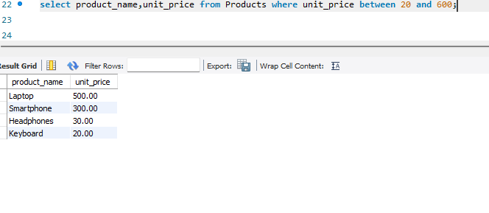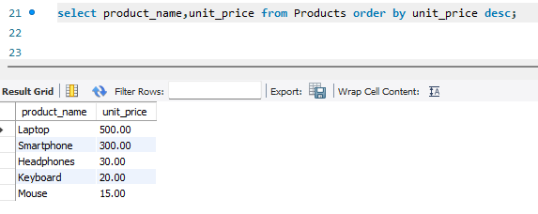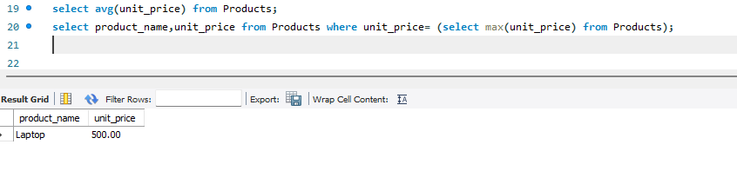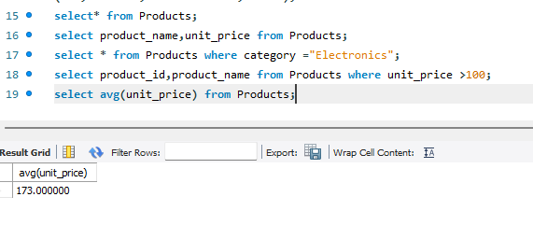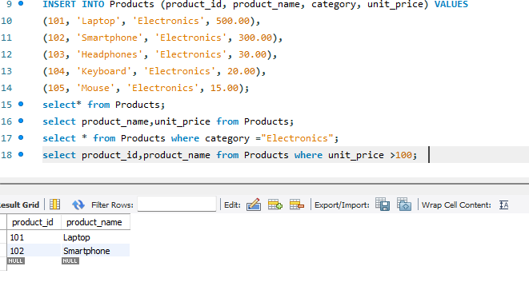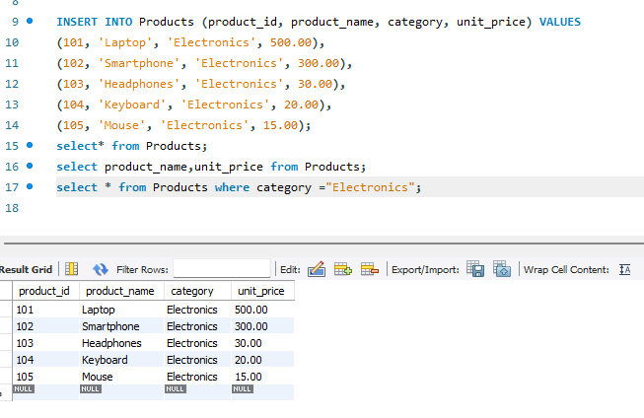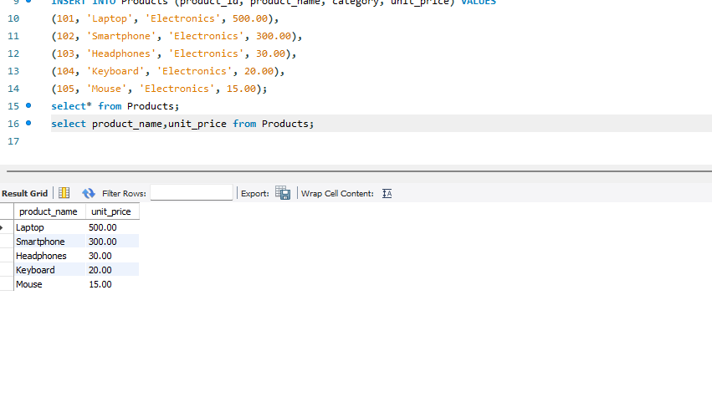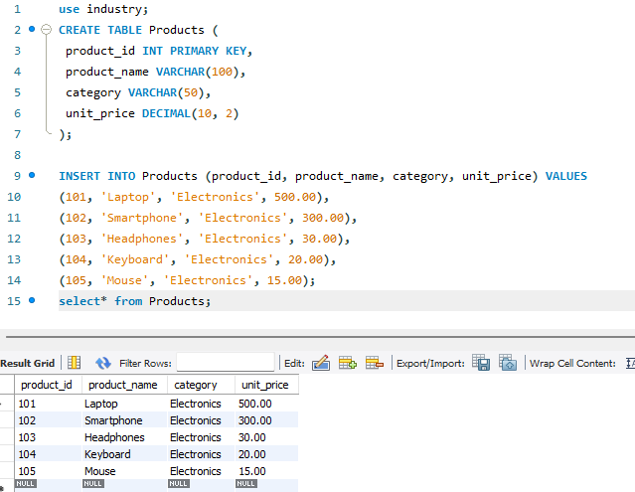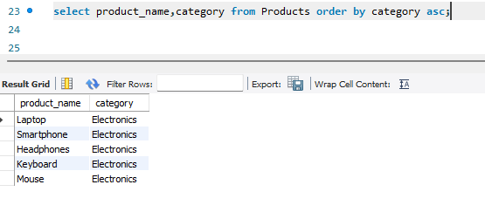

**PART-2:**

CREATE TABLE Sales (

sale_id INT PRIMARY KEY,

product_id INT,

quantity_sold INT,

sale_date DATE,

total_price DECIMAL(10, 2),FOREIGN KEY (product_id) REFERENCES Products(product_id)

);

-- Insert sample data into Sales table

INSERT INTO Sales (sale_id, product_id, quantity_sold, sale_date, total_price) VALUES

(1, 101, 5, '2024-01-01', 2500.00),

(2, 102, 3, '2024-01-02', 900.00),

(3, 103, 2, '2024-01-02', 60.00),

(4, 104, 4, '2024-01-03', 80.00),

(5, 105, 6, '2024-01-03', 90.00);

select*from Sales;

select sale_id,sale_date from Sales;

select sale_id,sale_date from Sales where total_price>100;

select sale_id,total_price from Sales where sale_date="2024-01-03";

select sum(quantity_sold*total_price) as total_revenue from Sales;

select sum(quantity_sold) as total_quantity_sold from Sales;

select sale_id,product_id,total_price from Sales where quantity_sold>4;

select avg(total_price) from Sales;

